Synchronous  Learning that involves group of students engaging at the same time | Benefits | Challenges
Student Experience | - Live--Real time interactions with instructors and fellow students  - Opportunity for discussion of complex issues  - Motivation to complete assignments | - Scheduling is an issue to deal with different regions and across time zones  - Low enrollment due to scheduling issues which affect cost
Instructional Delivery | - Instructor-centered approach  - Similar to face-to-face teaching models such as online polling, web browsing, task-based collaboration | - Instructors deal with multiple (often new) technologies without regular professional development
Technological Implications | - Audio/video conferencing  - Online Chat  - Instant Messaging  - White Boards | - Costly Learning Management Systems (LMS) that require high network capacity
Learning Outcomes | - Create opportunities for engagement and allow for instant feedback | - More research needed on improving student performance in online courses for cost effectiveness

Asynchronous  Student-centered learning method that uses online resources outside the constraints of time and place among people. | Benefits | Challenges
Student Experience  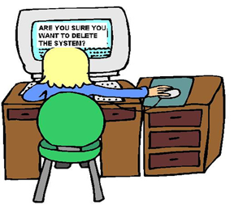 | - Learn at own time and pace  - Mostly simple content  - More time to reflect because sender does not expect immediate response | - Cannot get instant feedback because instructor is not present at a given time  - Must find time or means to communicate for group activities
Instructional Delivery | - Learner-centered approach  - Access materials when convenient  - Formats includes email, discussion boards and blogs | - Costly for first-time development, but long-term is cheaper than synchronous
Technological Implications | - Cost effective  - Computer Based Instruction (CBI)  - Recorded Webinars  - Games  - Videos | - Need to have technological tools  - Slower data transfer rate (especially in rural areas)
Learning Outcomes | - Opportunity to consider complex issues  - Great for non-traditional learners | - More hours of instructional preparation to measure student performance

